Seychelles Tourism Board.
General information for the tourists on the website is:
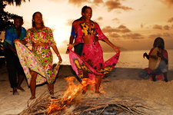
- Accommodation
- Best time to visit
- Special offers
- Travellers essentials
- Upcoming events
- Special interest sites.
- Thing to do
- Events
- Packages

The events the board helps organize to try and attract tourists:

They organize events every month. In April there is the Carnival, in May there is Miss Seychelles and FetAfrik, in August there are the fishing competitions, in September there is the Kreol Festival and the regatta festival.

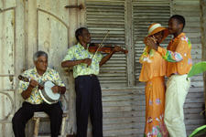
The products that are advertised on their website:

Seychelles products- Kreolor jewelry
-Black pearl jewelry
-Takamaka Bay coco rum
/ Dark rum/ White rum
-Kreol fleurage parfums
-Seybrew lager

Seychelles services- Island hopping (provides transportation to the main island)
-Bravo! (Restaurant)
-Breeze garden (Restaurant)

Does the tourism board try to attract businesses to come here for conferences, exhibitions…?

The tourism board does not really promote businesses to come for conferences, exhibitions, as there are not places for them to do their business, meetings etc. Also Seychelles is a place for family and a quiet holiday, and not for work. People leave Seychelles to go do their business abroad and not the other way round.

