**English First Language: WRITING**



**Miss B’s Revision Booklet**

**Name: ________________**

**About the Exam (Overview)**

**Paper 3 – Writing**

**Exam Date** – *Friday 8th May 2015 AM (2 hour exam)*

* Question 1: Directed Writing

This is a directed writing task (which means you are told exactly what to write about and how to write), which is usually based on one text. You will be required to use and develop this information into another form.

You may be asked to respond in a discursive/argumentative letter or article.

This question is worth **25 marks**: **15 marks** will be awarded for **writing** and **10 marks** will be awarded for **reading**. 250-300 words

* Question 2: Composition Task

You will be offered two questions; two for description and two for narrative. Writing to argue has been removed (as it is now more clearly included in question 1).

You only need to complete ONE of these tasks, ensuring you choose the best task for you.

This question is worth **25 marks** and will be **marked entirely on your writing skills.** This comprises of two different marks: a maximum of **12 marks** will be available **for style and accuracy;** a maximumof **13 marks** will be available **for content and structure.**  350-450 words.

You will be marked on the following skills:

Reading:

• R1 Demonstrate understanding of explicit meanings

• R2 Demonstrate understanding of implicit meanings and attitudes

• R3 Analyse, evaluate and develop facts, ideas and opinions

Writing:

• W1 Articulate experience and express what is thought, felt and imagined

• W2 Sequence facts, ideas and opinions

• W3 Understand and use a range of appropriate vocabulary

• W4 Use register appropriate to audience and context

• W5 Make accurate use of spelling, punctuation and grammar

**Hints and Tips**

**Section 1**

* For this question, you will need to put yourself into role, and address your audience directly. The opening needs to introduce clearly the situation and purpose of the task, and will be rewarded if it puts the reader in the picture.
* You need to be clear and often persuasive/argumentative in tasks like these, so imagining that you are addressing someone in front of you might help you to keep that in mind. Do not be overly casual though - this is a formal piece of writing. Even if it is for your peers in a school magazine, written language for publication is less colloquial than spoken language.
* Your answer will not be in the same genre as the text(s), and should therefore be in a different style from it/them.
* You should try to use as many ideas from the passages as possible as they will all be relevant, but you will have to change the way you express them; all the material you use from the passages must be modified to suit the new genre.
* Do not write as yourself unless you are specifically told to do so and keep in mind why you are writing – for example are you meant to be persuading someone or offering advice?
* The recommended structure for the response will be offered in the wording of the question, and you should follow this.
* There will be at least two factors to focus on – for example advantages and disadvantages. You will need to make two lists before you start in order to make sure you have enough material for both sides of the question.
* The third element of this question is evaluation; you will have to decide which of the options is better, present reasons why you have formed this opinion and justify it.
* Keep your focus on what the question is asking you to do. Do not get distracted by peripheral issues; for instance if you are asked how money should be spent, don’t discuss the fund-raising methods.
* Make strong transitions between points/paragraphs e.g. ‘Yet another reason to support this proposal is...’ You need to link your ideas together logically so that if someone in real life was reading this response they would follow what you are saying step by step.
* Though you cannot make up things which are not in the passages, you should try to use your own ideas in the way that you extend those of the passages, provided that they are ‘based on the reading material’.
* The ending needs to be definite and provide an effective and satisfying conclusion to the piece.

**Section 2 - General**

* It is essential that out of the four titles available you choose a question which you understand and which suits your writing abilities.
* Though the two different genres (narrative and description) are marked according to the same mark scheme for Style and Accuracy, they are marked differently for Content and Structure. The three two genres are different from each other, so you need to be aware of the characteristics of each.
* Whichever type of essay you choose, it should be planned first. If after 5 minutes you have managed to collect only a few ideas for your choice of title, switch to another one. The plan should contain between 6 and 10 points or ideas, which can be developed into paragraphs, if the essay is going to be of a suitable content and length. Aim for about 8 paragraphs and 400 words.
* Openings to compositions are important as they either engage the reader or they don’t. Try to grab your reader’s attention from the start.
* Take the opportunity to show off your range of vocabulary – find precise words to use and vary your choices.

**Descriptive compositions**

* It is difficult to write interesting descriptions, so make sure you do lots of practice beforehand (you can hand anything in to me). To write a strong descriptive answer you will need to use a wide range of vocabulary and even use imagery to engage reader interest. Unless the readers can see the picture they will not be able to relate to the experience.
* You will need to use a variety of sentence structures. All forms of repetition should be avoided – unless you are deliberately using it carefully for effect.
* You will need to evoke all five senses to create an environment and atmosphere, as well as details of size, shape and colour. Make colour precise, e.g. ‘scarlet’, ‘azure’, ‘off-white’, ‘bluish-grey’.
* Try to avoid common, overused, vague, short and childish vocabulary, such as ‘nice’, ‘big’, ‘little’, ‘a lot of’, ‘good’, and ‘bad’.
* Each noun probably needs one or more adjectives in front of it to give sufficient detail.
* Don’t let your description become static – give structure and progression to your description e.g. moving towards or through something, such as a street market or busy shopping mall, or going through a period of time, an hour or a day for instance, and recording the changes.

Descriptive compositions must not become a narrative, which means character and event should not take over or be dominant. (You can have lots of description in a story but you should have as little “story” in a description as possible.)

**Narrative compositions**

* Decide on a tense and then stick to it; do not jump between present and past. The normal narrative tense is past and those who try to write in the present usually forget to do so after a while, so it is safer to start off in the past if you are unsure.
* Know what your last sentence is going to be before you write your first. A narrative has to build up to a climax and lead towards a conclusion which is planned before it starts or it will end lamely or incomprehensibly, or the pace will be too slow or too fast.
* Don’t try to do too much; you can’t cover many events and many years in one short composition. Select key moments and skip over the rest, changing the pace according to the intensity of the moment.
* Don’t try to include too many characters (generally no more than than three is best). Don’t try to give them all speech.
* For the top band, complexity of narrative and structure is required e.g. framing the story; flashback or forward time jump; two parallel strands being brought together.
* Use dialogue by all means (if you can punctuate and set it out correctly) but don’t overdo it. You shouldn’t turn your story into a play, nor should you dilute the effect of occasional and significant moments of speech by giving the characters trivial things to say throughout. Save speech for important moments.
* If you do use dialogue, find synonyms for ‘he said/she said’.
* Even narrative needs description. You need to help your reader imagine characters and places by adding significant details to bring them alive.
* Choose to tell your narrative in first or third person and stick with your choice; do not switch viewpoint accidentally, as this is confusing for the reader.
* Don’t end your story with ‘And then I woke up in hospital’, or ‘It was all a dream’. Try to avoid clichés of any kind, including stereotypical characters and predictable outcomes.
* Use similes, but avoid obvious ones such as ‘as red as a rose’. Make comparisons unusual, but still apt, by giving them a moment’s thought and making them more specific e.g. ‘as red as a matador’s cape’.
* Use plenty of interesting details to engage your reader and make them want to read on.
* Don’t exaggerate; too much blood or too many unlikely events become ridiculous, and fear is more believable when it is mental rather than physical.
* Use your own knowledge and experiences as inspiration. It is better to think of something that actually happened to you, or someone you know, or which you read in a book or saw in a film, than to try to make up something entirely from scratch. It will sound more convincing. You will need to adapt, embellish and exaggerate the original idea to make it relevant, fresh and memorable – just retelling the plot synopsis or giving a factual account is not likely to interest your reader.
* Keep a balance in the different parts of the narrative. An over-long introduction reduces the effect of the middle section where things build up to a climax, and you need to leave yourself time to create a memorable ending.
* End your narrative deliberately. Stories need a conclusion, where things are either resolved or purposely left unresolved as a cliff-hanger (though on the whole readers prefer to know how a story ended). You must not give the impression that you just stopped writing because you ran out of time, ink or ideas.

**Useful Websites**

* [www.englishbiz.co.uk](http://www.englishbiz.co.uk)
* [www.topmarks.co.uk](http://www.topmarks.co.uk)
* <https://igcse-revision.wikispaces.com/Descriptive+Writing>
* <https://www.youtube.com/watch?v=fe1WWBrNf8M>
* <http://blogs.yis.ac.jp/kewt/2012/02/20/igcse-advice>

**Mark Scheme**

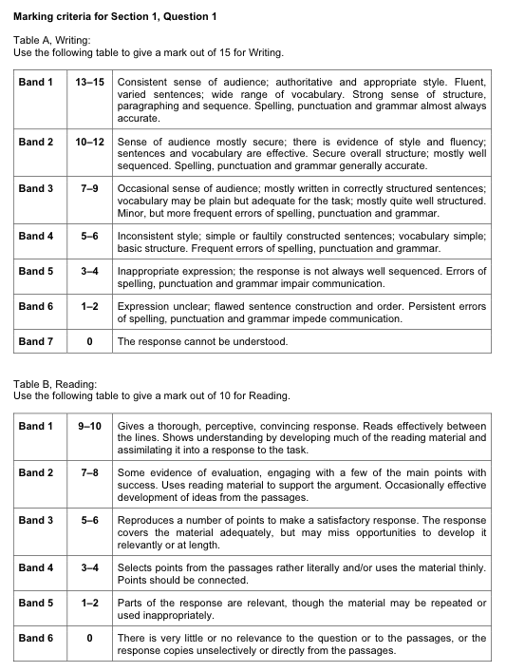

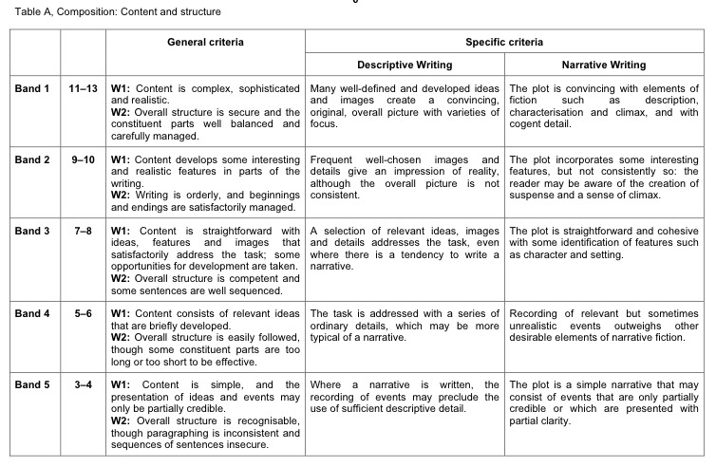

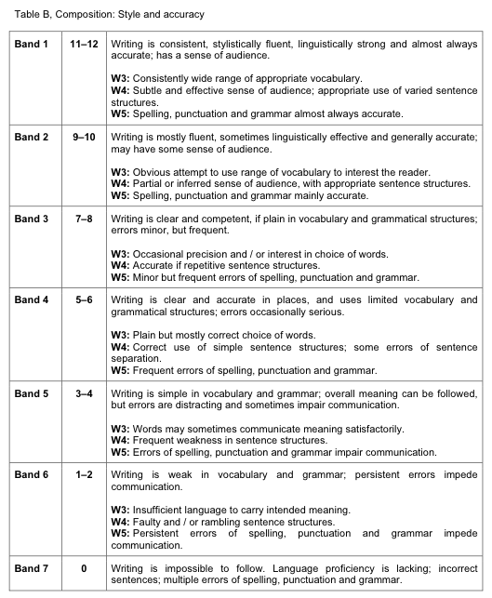

**Examples of Student Work**

**‘B’ Grade Question 1 Response:**

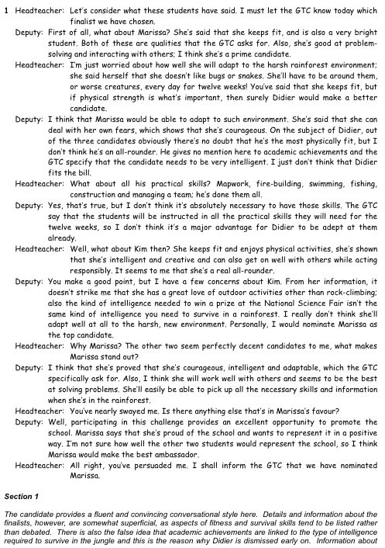

**‘A’ Grade Narrative:**

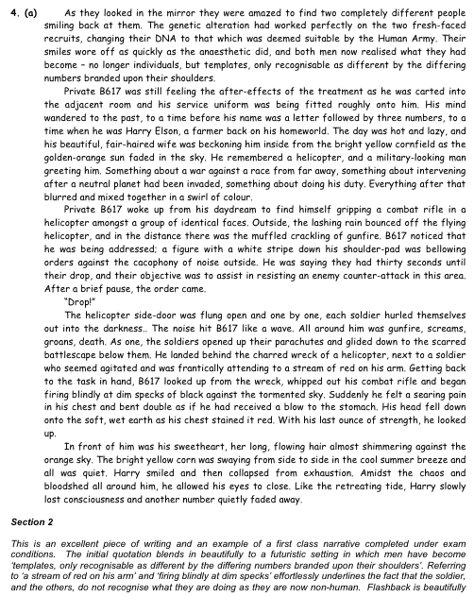

**‘A’ Grade Description:**

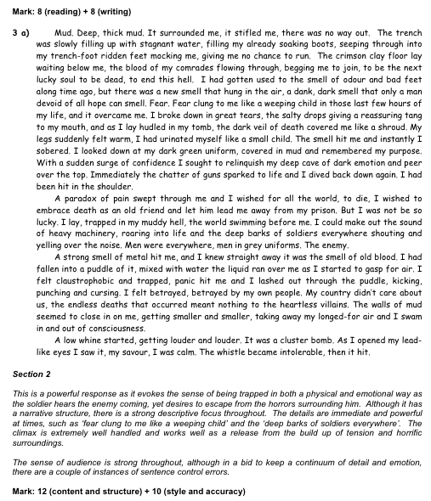

**Past Questions: Writing Compositions**

**Writing to describe: Descriptive Writing**

* You come across an abandoned building you never knew existed. Describe its exterior and surroundings before giving details of how you enter. Describe the atmosphere inside and everything your senses experience as you explore the building.
* Describe a place called ‘Paradise on Earth’.
* Describe the best meal that you ever had with a group of people, including details of the place and the atmosphere.
* You arrive at an airport or railway station to discover that there is a long delay. Describe what you see and hear, and your thoughts and feelings while you are waiting.
* Describe the most disappointing gift you have received and your reactions at the time.
* You are in a place which you feel may be haunted. Describe the place, and your feelingsand reactions.
* Describe a building, and some of the people who enter and leave it, during the short period while you are watching the entrance.
* ‘It was all over in a moment.’ Describe what happened at that time, what you saw and heard, and your feelings.
* You arrive on an island. Write a description of your first impressions of the place and its people.
* **D**escribe what you see and hear from a hiding place.
* Describe children playing with a grandparent.
* Describe a time when you felt homesick. Where were you at the time, and what were your thoughts and feelings?

**Writing to narrate: Narrative Writing**

* Write a story entitled ‘The Great Pretender’.
* Write about how an old film had been obtained secretly.
* You see someone in a crowd whom you recognise but you can’t think why. On noticing you, the person moves away, and you instinctively follow. Write the story.
* Write a story which begins with someone hearing an eerie and unidentifiable noise.
* ‘The figure in the long, black coat.’ Use this as the title of a narrative.
* Write a story which takes place in extreme weather conditions.
* ‘If only you’d told me this earlier, it would have made all the difference.’ Write a story which begins or ends with this speech.
* Write the story of what happens when someone opens a box labelled ‘Do Not Open’.
* You witness an incident which you are forced to get involved in. Use this idea as the basis for a narrative.
* Write a story based on an animal that escapes.
* Write a story called ‘The Rock’.
* ‘The lady, her face barely visible through the thick lace veil, turned the card over to reveal...’. Begin or end a story with these words.

**Revision Strategies and Advice**

1. As you read different types of texts in English, try to notice how they sound different from each other and how they compare.
2. Practise joining simple sentences into complex sentences, using a range of connectives and participles. Above all avoid using ‘and’, ‘but’ and ‘so’.
3. Practise varying your sentences to develop your own style. You don’t want your sentences all to follow the same formula and start in the same way.
4. Learn the correct version of commonly misspelt words which you know you are likely to need to use e.g. separate, definitely, business, opportunity, surprise, privilege.
5. Revise direct speech punctuation. It is likely that in one or more parts of the examination you will be required to or will wish to use dialogue. Remember in particular that a change of speaker requires a change of line, and that all speech needs a final punctuation mark in addition to the closing inverted commas. Remember also that exclamations and questions that fall inside the speech are not followed by a capital letter if the sentence continues, and that commas not full stops are used to end speech unless there is no continuation to the sentence. e.g. ‘Really?’ she asked. ‘Really,’ he answered.
6. When you are practising your writing you should try to broaden the range of the connectives you use. Be aware that there are over thirty connectives available in English for joining parts of sentences (clauses) together. Challenge a friend to see how many you can think of without looking them up.
7. Practise persuasive writing. The exam is weighted towards this life skill in both the reading and writing papers. Support all points with proofs and think about how you might persuade your reader – for example the use of threes, rhetorical questions, direct address.
8. Read lots of openings to stories and practise beginning the same story in different ways. You could start: by setting the scene, referring to place and time, season and weather, with description of the main character, in the middle of the action, in the middle of dialogue, with an intriguing or shocking statement
9. Think about your narrative endings. Write a plan for a story and then experiment with different ways to end it: an unexpected twist, a return to the beginning, a happy ending, a sad ending, a cliffhanger. But DON’T end the story by waking up from a dream - that just means that as a writer you couldn’t think of an ending to explain what had happened in your story in any other way – a sure sign of poor planning!
10. To improve your writing further, learn those little things you’ve always got wrong and never bothered to work out why e.g. the difference between it’s (it is/it has) and its (belonging to it); who’s (who is/who has) and whose (belonging to who); continuous (without stopping) and continual (with stops); uninterested (without interest) and disinterested (without prejudice); lay (with object) and lie (without object).
11. Remind yourself of any punctuation marks of which you have never been sure. You could revise the rules for the use of the apostrophe (missing letter or possession) or the hyphen (using two words as one) or starting a new paragraph (change of time, place or topic) or commas (particularly subordinate clause). Lack of paragraphing is particularly detrimental to your mark.

