Where in the World
City | Country | Famous landmark
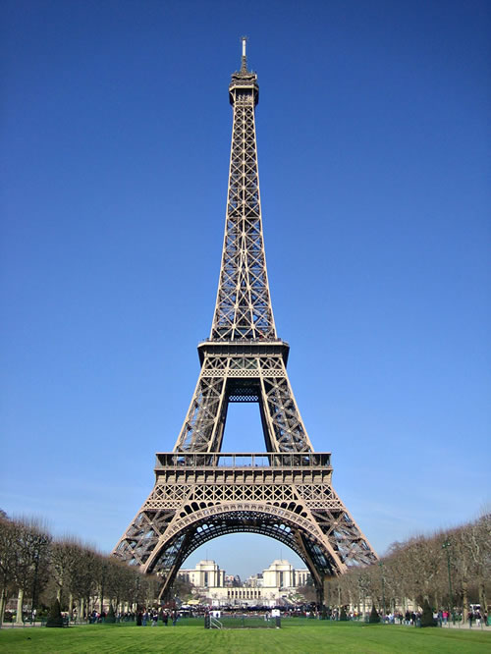
Eiffel Tower
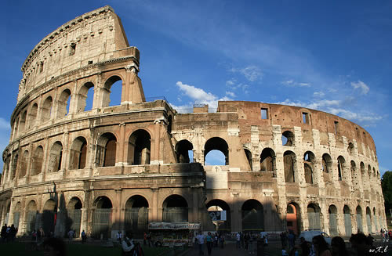
Colosseum
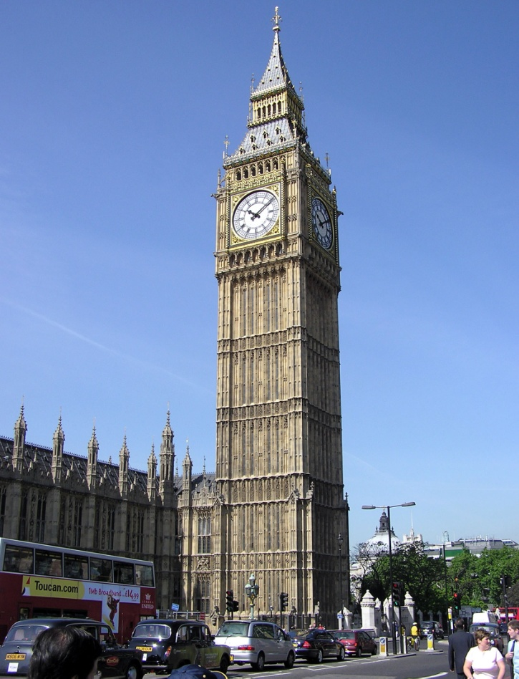
Big Ben
Agra
Cairo
 |  | Moai Statue
 |  | Christ Redeemer Statue
 |  | The Statue of Liberty
 |  | Kaaba

Extension:
Using Microsoft Paint, draw one of these famous landmarks:

Easy: Pyramids
Medium: Big Ben
Hard: Eiffel Tower

